PRODUCT REQUEST FORM
PRODUCT NAME: | Sterile Level 2/3 Gowns
DESCRIPTION OF REQUEST:  - New Product  - Modification  - Product Extension  - Country addition  - Label Change  - Intended Use  -…Etc… | Project Background  The $15.6 billion U.S. compounding pharmacy market operates under the stringent requirements of USP <797> for sterile compounding. Compliance mandates the use of appropriate barrier apparel to maintain the integrity of the ISO 5 controlled environment. Sterile surgical gowns (AAMI Level 2 for moderate, Level 3 for high liquid barrier protection) are an essential component of personnel attire for all sterile preparation activities.  The most efficient and strategically sound approach is to distribute gowns from an established, reputable U.S. manufacturer. This strategy:  - Provides immediate compliance assurance to pharmacy customers with products that have pre-existing AAMI certifications and 510(k) clearance where applicable.  - Eliminates substantial upfront risk and resource allocation, allowing us to focus on commercial execution and customer relationship building.  - Completes a core segment of our Sterile Compounding PPE offering, enabling us to present a fully integrated “Gown-to-Glove” sterile attire solution alongside our Sterile Nitrile and Chemo Gloves.  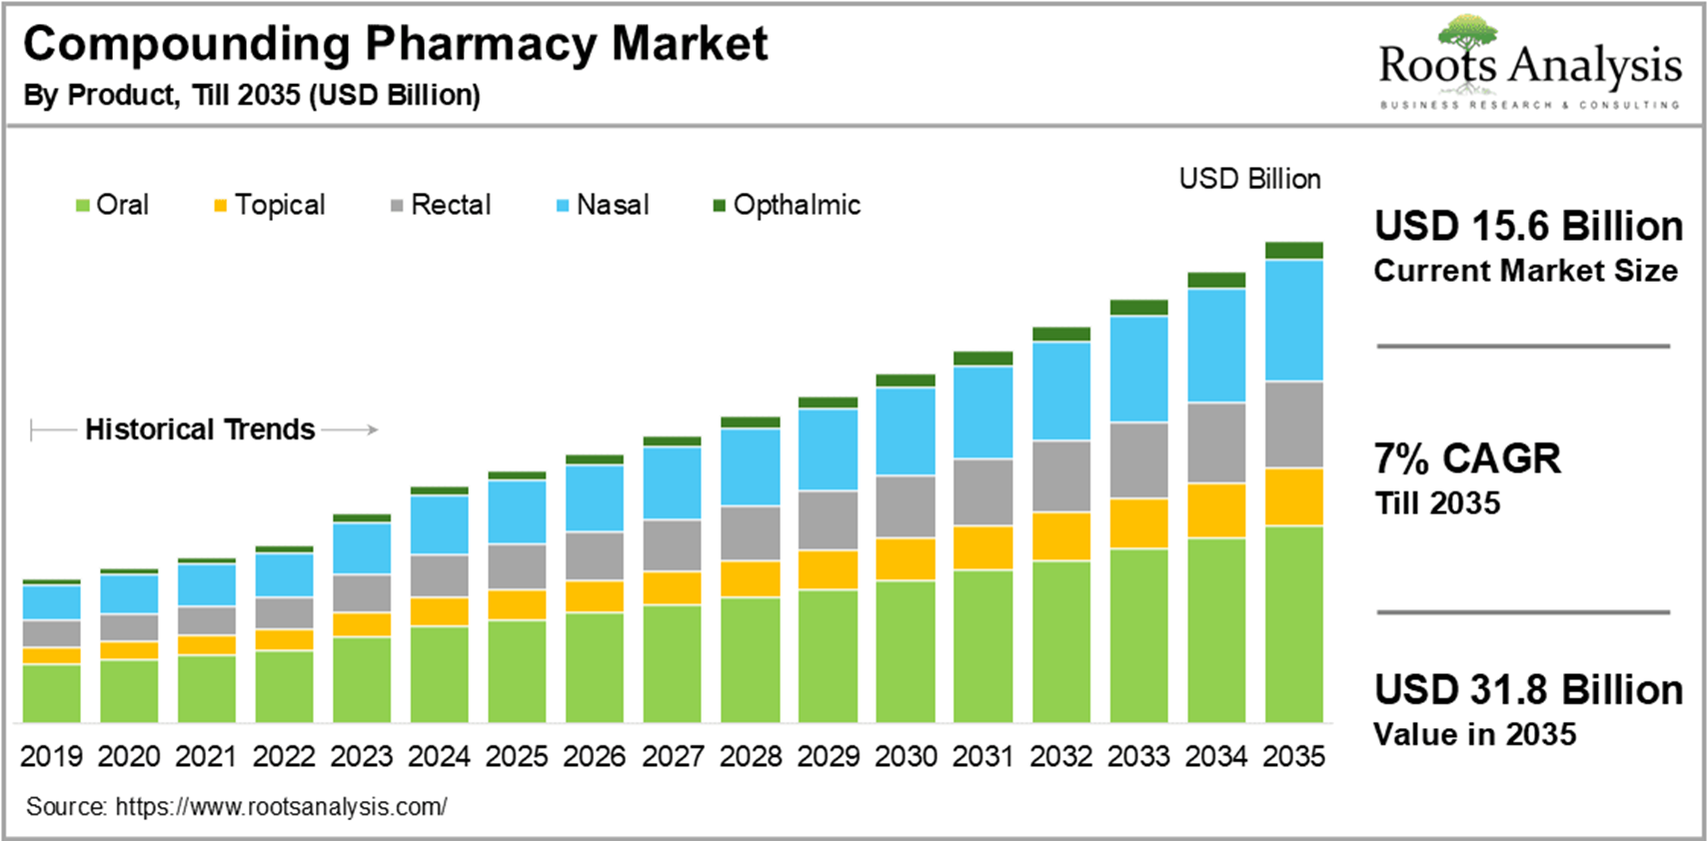
PURPOSE OF REQUEST: | ☐Complaint No. ☐Supplier ☒New market_______US_________  ☐Customer ___ ☐Internal _ ☐Other________________________  Add details:
ESTIMATED BENEFITS: | ☒ Financial Benefit:_Complete the product lines for the Compounding Pharmacy markets, Annual sales amount $ 60M (Mandatory For NPD request)  Estimate the potential increase in cash flows, revenues, or any other financial benefits  ☐ Cost Saving:__________  Decrease in the cogs, transportation or operation expenses, or any other cost-saving opportunities  ☐ Improved Operational Efficiencies:_________  Decrease in the Lead time, delivery time, MOQ, Inventory, or any other efficiency improvement  ☐ Non-Financial Benefits:_________  Quality Improvement; Enhanced customer satisfaction, product competition, Brand reputation, etc.  ☐ Other Benefits:__________
PRODUCT DESCRIPTION:  - Functional performance requirements  - Appearance  - Any unique points of differentiation against similar competitor product lines  . ..Etc… | Product Definition & Scope 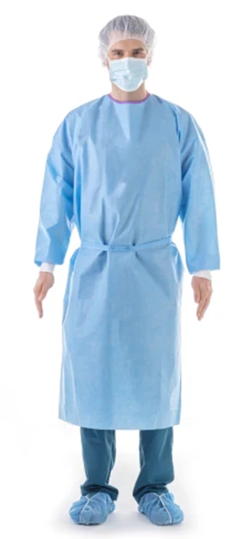  - Product: Sterile, disposable surgical isolation gowns, rated to AAMI PB70 Level 2 (moderate barrier) and Level 3 (high barrier) liquid protection standards.  - Primary Use: Worn by compounding personnel during sterile product preparation within a laminar airflow hood (ISO 5 environment) to protect the compounded preparation from human-borne contaminants.  - Partner Profile: A U.S.-based manufacturer with a robust track record in producing sterile gowns for the healthcare market, possessing all necessary cGMP and 510(k) clearances where applicable, and a commitment to consistent quality.  3. Agent Brand Proposal  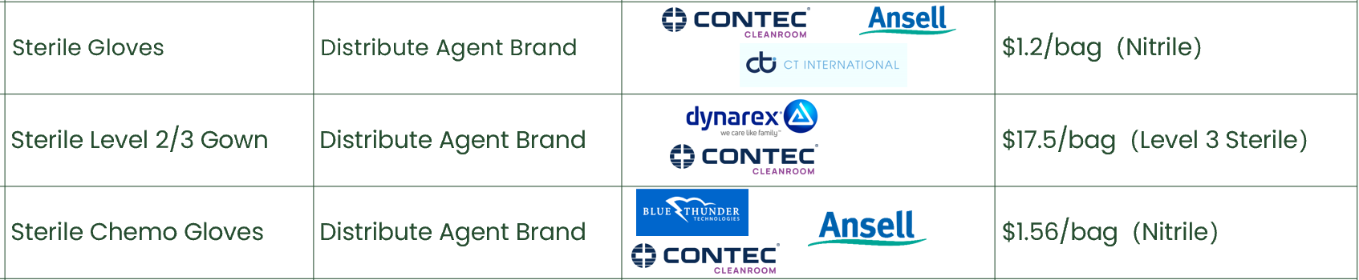
REQUEST TYPE | ☐LCR (Labelling Change Request)  Changes on the labels without changing the products  ☐SCR (Supplier Change Request)  Change applications initiated by Suppliers  ☐ECR (Engineering Change Request)  Existing products that SOLM is the legal manufacturer  Engineer changes that are not bringing new hazards/risks  ☐NPD (New Product Development)  Develop new innovative products that SOLM will be the legal manufacturer  Significant changes on existing products that may bring new hazards/risks or new intended use  Change products from outsourcing to SOLM to be the legal manufacturer  Development of VET/Component products  ☒SDP (SOLM Distributor Product)  New product introduction that SOLM will not be the legal manufacturer  No change on the product, no SOLM information on the labels  ☐SPP (SOLM Portfolio Product)  New product introduction that SOLM will not be the legal manufacturer  No change on the product, Add SOLM information on the labels  ☐Customized Product / Market  Purchased products that SOLM is not the legal manufacturer  Engineering change on products or new customized products requested by SOLM  New Market region requested by SOLM
TARGET MARKET: | ☒ US ☐ Canada ☐ EMEA ☐ UK ☐ Brazil ☐ Australia & New Zealand ☐ Other countries/regions, list:
TARGET USE: | ☒ Human Use  ☐ Animal Health | STERILE | ☒ YES  ☐ NO
VOLUME/SALES OPPORTUNITY: | Launch volume required: | Yr 1 estimate | Yr 2 estimate
CUSTOMER NOTIFICATION | Do we have any special quality agreement in place with customer which requires approval before implementing changes? ☐ YES ☒ NO  If Yes, please provide the customer's name and evidence.  Attach the customer confirmation GF-0083 at the end of the form.  Is notification to the customers needed after change project is closed? ☐ YES ☒ NO  Remark:  Example: change affect regulatory, performance, appearance, etc. Notification method.
LEGAL MANUFACTURER: | ☐ Sol-Millennium  ☒ Other: __________ | BRANDING | ☐ Sol-Millennium  ☐ Private Label
EXPECTED PRODUCT LAUNCH PERIOD: | ☒ < 1 year  ☐ 1-3 year  ☐ > 3 years | EXPECTED PRODUCT LIFE PERIOD: | 10 years
NAME AND DATE of REQUEST: | Alex Lu 2026/2/10

Product | COO | McKesson Uni Price | Target Uni Price | Target Gross Margin | Annual consumption in US | Solm采购量（10% ） | Est. Sale Revenue
Sterile Level 2/3 Gowns | US | 1.97 | 1.20 | 40% | 500,000,000 | 50,000,000 | 60,000,000

